|  |  |
| --- | --- |
| **Ex.No:5.A** | **Linear Search** |
|  |

***Aim:***

To develop a python program to perform linear search in a list of numbers.

***Algorithm:***

|  |  |
| --- | --- |
| **Step 1:** | Start Process |
| **Step 2:** | Get a list of numbers from user and store id alist. |
| **Step 3:** | Get a number to be searched from user and assign to key. |
| **Step 4:** | Assign found as False |
| **Step 5:** | Get a next element in the list and compare with key. |
| **Step 6:** | If key is equals to element set found as True and goto Step |
| **Step 7:** | Else goto Step 5 |
| **Step 8:** | If found is equals to True then print “Element Found” and goto 10 |
| **Step 9:** | Else print “Element not Found” |
| **Step 10:** | Stop Process |

**Flow Chart:**

**Pseudo Code:**

START

READ alist

READ key

ASSIGN found = FALSE

WHILE no more element in the list

element = next element

IF element is equals to key THEN

found = TRUE

BREAK

END IF

END WHILE

IF found equals to TRUE

PRINT “Element found”

ELSE

PRINT “Element not Found”

END IF

STOP

**Program:**

print("Linear Search")

print("-------------")

alist = []

print ("enter any 5 numbers")

for i in range(5):

data = int(input())

alist.append(data)

key = int(input("Enter any number to search"))

found = False

for element in alist:

if (element == key):

found = True

break

if(found):

print("Element Found")

else:

print("Element not Found")

**Output:**

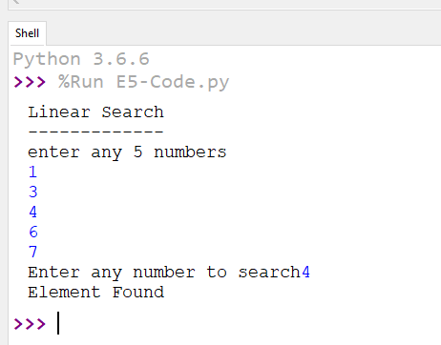

***Result:***

Thus the program to perform linear search in a given list was developed and tested successfully.